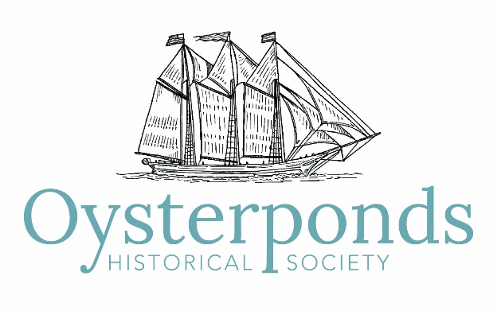

Minutes of the Oysterponds Historical Society Annual Meeting
November 17, 2018

1. WELCOME – The Oysterponds Historical Society Annual Meeting was called to order at 10:35 am. Co-presidents Leslie Koch and Ed Caufield welcomed everyone for coming. The complete power point presentation of the meeting can be found on the OHS website under About, Presentations and Financials.

2. YEAR IN REVIEW – Interim Executive Director John Holzapfel and Co-Presidents Leslie Koch and Ed Caufield presented the 2018 exhibitions, programs and accomplishments.
This past year there was an increase of visitors to OHS: visitors came from thirty-one (31) states and eleven (11) countries.
a. 2018 Exhibitions created by Curator Bill McNaught
- Baskets
- Abraham Tuthill, Orient artist
- Ceramics, Transferware and Stoneware
- New Acquisitions
- World War II Posters
- Ship Models
- Quilts

b. Education Programs
- In support of the Abraham Tuthill exhibition the Education Committee filled display cases at the Oysterponds Elementary School with artwork, maps and charts by Oysterponds artists.
- Farm to Table field trips to coincide with the OHS 2018 program theme.
- Summer Activities and OHS Kids

c. Programs supporting the 2018 Farm to Table theme
- A Long Island Vegetable Factory
- The Flavor and History of the Peconic Bay Scallop
- Psalms and Boiled Bread
- Family Workshop: Herbs and Flower Planting
- Quilts
- Oysters in Early Manhattan: Colonial Trade Artifacts
- Artisan Basket Workshop
- Heritage Day
- Fall Festival
- Drawing Workshop
- Silversmithing on Long Island
- Armistice Celebration
- Winter Sing, scheduled for December 10th at 4 pm in Poquatuck Hall

d. Buildings and Grounds
- The Red Barn has been restored and painted
- There are new light in front of Webb House and the Hallock Building
- New window wells have installed at the Old Point Schoolhouse
- Leak in Village House had been addressed
- Webb House has a new roof and is being painted

e. Fund Raising Events
- North Fork Fresh – netted $44,000.00
- Summer Benefit and Art Auction – netted $140,000.00
- Houseman Dinner – Tuesday, January 29, 2019, 6-9 pm

f. Upcoming Events
- Beach Plum Holiday Shop at the Old Point Schoolhouse will open the Saturday after Thanksgiving
- Holiday House Tour – December 8th
- Webb House Holiday Party – December 8th

g. Accomplishments
- The new website is up and running.
- Ann ffolliott, chair of the Collections Committee reported that OHS was awarded a grant of $53,000.00 from the Gardiner Foundation to be used for collections care.
- A Maritime Restoration Fund has been established to restore the collection of ship models and marine paintings.

Many thanks to our past executive director, Elsbeth Dowd, to our staff Karen Haley, Colin Palmer, Bill McNaught and Amy Folk, and to all our one hundred fifty-four (154) volunteers. Working together we are able to collect, preserve and interpret the history of Oysterponds.

3. LOOKING AHEAD – Co-presidents Leslie Koch and Ed Caufield and Curator Bill McNaught discussed the goals, programs and exhibitions for 2019.
a. A search committee, headed by Stephen Rotella, has been formed to recruit a new executive director.
b. A major goal is to concentrate on the preservation of the collection.
c. 2019 Exhibitions
- Modern Architecture on the North Fork
- Weapons, swords firearms, etc.
- Model Looms and Samplers
- Photography of L. Vinton Richard ( friend of William Steeple Davis)
- 75th Anniversary of OHS
- Oysterponds and the Civil War

4. FINANCIAL REPORT – Treasurer Allison Forstmann presented the financial report: past, present and future. OHS has hired a new bookkeeper.
a. Past: The 2017 audit is being processed and should be completed by the end of the year. Howard Shainker is the chair of the Audit Committee which was formed in 2018 and is separate from the Finance committee.

b. Present: We are in good shape financially and the operating budget is on target. There was a record revenue of $170,000.00; we received a grant of $53,000.00 from the Gardiner Foundation restricted for collections; and to date we have gotten $24,000.00 toward the restoration of the maritime collection. Currently the expenditures for payroll includes three part-time employees and two full time employees.

c. Future: The operations budget remains stable. The challenges for 2019 will be to continue to address the collections and campus plan. There has also been a suggestion to establish a Planned Giving Campaign for 2019.

5. ELECTION RESULTS – The 2019 Trustee Slate was approved unanimously.
The 2019 OHS Board of Trustees is as follows:
Executive Board:
Co-Presidents – Leslie Koch and Ed Caufield
Vice President – Ann ffolliott
Treasurer – Allison Forstmann
Secretary – Karin Constant

Trustees:
EJ Camp
Christine Churchill
Leslie Cohen
Jeffrey Davis
Suzanne Gluck
Robert Hanlon
James Harris
Lydia Irving
Angela Meredith-Jones
Steve Rotella
Sandra Saiegh
Howard Shainker
Fredrica Wachsberger, Emerita
Diana Whitsit
Ellen Zimmerman

6. The Annual Meeting was adjourned at 11:40 am.

