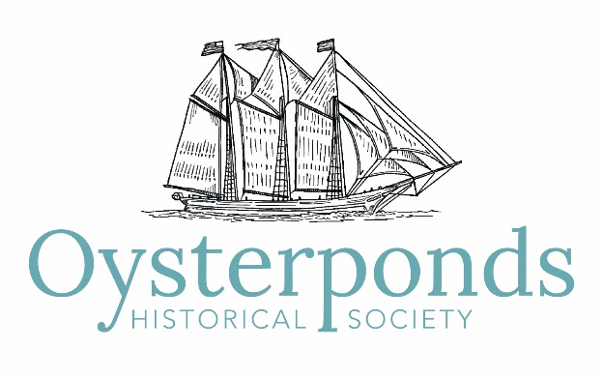

Minutes of Board of Trustees Meeting
March 16, 2019

Attendees: Co-Presidents Leslie Koch and Ed Caufield (phone-in); Executive Director Marianne Howard; Interim Director John Holzapfel; Trustees Ann ffolliott, James Harris, Sandra Saiegh, Diana Whitsit, Ellen Zimmerman, Steve Rotella, Allison Forstmann, Robert Hanlon, Lydia Irving, Karin Constant

Guest: Jessica Frankel, NFF Chairperson

1. The meeting was called to order at 10:30 am.

2. Approval of Minutes
A motion to approve the minutes from the February 3, 2019, board meeting was unanimously approved.

3. Interim Director Report
John Holzapfel reported the following updates:
- The Red Barn project is completed.
- The leak at the Village House has been identified and repaired. A temporary fix for the roof is currently being addressed.
- The hallways in the Webb House have been painted. Bids for the roof and fascia are currently in the works.
- The model train and the model of the USMS Georgia are now on permanent display in Village House.

4. North Fork Fresh
Jessica Frankel, Chairperson of NFF updated the board of trustees on the progress of the event:
- NFF will take place on Saturday, June 15, 2019, from 5:00 pm to 7:00 pm.
- All necessary items have been rented.
- The invitation art work is complete.
- Nine (9) vendors have signed up so far and six (6) raffle baskets have been assembled. In addition to items that reflect the North Fork, the raffle will also include North Fork “experiences and opportunities.” Raffle tickets will cost $25 each. Every Board Member will be given 10 tickets to either buy or sell.
- A few tickets to the event have already been sold.
5. President’s Report
President Leslie Koch reported the following:
- Congratulations to Marianne Howard for a very successful transition into the OHS community.
- The Board of Trustees has dedicated the planters at OHS to John and Joyce Holzapfel in recognition of all their dedication, support and hard work to the society.
- OHS Board of Trustee member Robert Hanlon is a candidate for Southold Town Board in the 2019 election.
- EJ Camp has stepped down as a member of the board of trustees. She will concentrate her efforts on the Summer Benefit and Art Auction.
- The Halyard Cocktail Party is scheduled for Saturday, April 13, 2019, from 5:00 pm to 7:00 pm. This event is a meet and greet for all members of the Oysterponds Community and an opportunity to meet Marianne Howard.
- New Committee Chairpersons:
Sponsorship – Sandra Saiegh
Membership – Suzanne Gluck. Giving circles will be explored.
- Summer Benefit and Art Auction will take place on Saturday, August 3rd. EJ Camp and Leslie Cohen will chair the art auction. An event chairperson is still needed.

6. Executive Director Report
Marianne Howard reported on the following:
- Marianne will be meeting with Freddie Wachsburger on the Eleanor Williams house in April.
- Database CRM – Flipcause is now operational on the website. Tickets, memberships and donations are now done on the new system. We have exported the Netforum data. It will be imported and updated in the next couple of weeks. The new system should be totally operational by early-mid April.
- Currently 30 tickets have been sold for the Halyard Cocktail Party. Another reminder went out on 3/15, and a regular schedule of eblasts for the event will follow. This is a great opportunity to welcome any new people from Orient and East Marion to OHS.
- Marianne and Leslie Cohen have conducted a second round of interviews for the new External Affairs Manager position.
- The total donations that have come in to OHS in honor of Doug Constant is $2,830.00.
- More items have been brought for conservation in the maritime collection. Amy Folk has made another trip to bring more ship models in for conservation.
- Draw down is completed: $85,115.28.
- Finalizing dates for the 2019 programming. All programs will start after Memorial Day. Please save the date for the exhibition opening reception on Sunday, May 26th. A weaving program has been scheduled for July 13th.
- Marianne will meet with Oysterponds School Superintendent, Richard Malone.
- A 75th Anniversary banner will be displayed at Village House.

7. Finance Committee Report
- Attached to the agenda was the 2019 budget, the 2019 monthly cash flow for January and February, and the minutes from the Finance Committee Meetings on February 26, 2019, and March 12, 2019.
- A decision was made to move the Capital One accounts to Chase Bank in Greenport.
- Our current Signatory Policy is being reviewed.
- OHS continues to progress and grow in a positive financial direction.

8. Collections Committee Report
- Attached to the agenda was the Collections Committee Report from the February 21st meeting.
- Ann ffolliott, Chairperson of the Collections Committee, discussed the OHS deaccessioning policy.
- Items that can be deaccessioned must be either broken, inappropriate, needlessly duplicated, free from donor-mandated restrictions, legally owned by the Society, been a part of the collection for more than 3 years, have been lost or stolen and missing for more than 2 years, or determined to be a fake or forgery or has been misattributed.
- The Society will dispose of deaccessioned items through transfer to the educational program, through a well-advertised third-party auction, or by exchange or gift to another museum or historical society. No deaccessioned items will be sold through the Society’s gift shop. Items that have deteriorated beyond usefulness will be disposed of in an appropriate manner.
- The board must approve all deaccessions by a majority of the quorum.
- The committee considered Collection items that Amy Folk and Bill McNaught have recommended for deaccessioning – several baskets and a small chest of drawers used in a Village House bedroom which is now redundant. The baskets are broken and the chest of drawers will be replaced with a historically appropriate one donated by the late William Schriever.
- A motion to deaccession the group of baskets and the small chest of drawers was unanimously passed. The baskets will be disposed of and the chest of drawers will be given to the Stirling Historical Society in Greenport.
- Ann gave a report about the Gardiner Grant project, attached here.

9. Membership Committee
The Membership Committee is considering ways to reach out to new members of the Oysterponds community through welcome baskets and perhaps providing people with research about their properties.

10. Old Business
Diana Whitsit will discuss last year’s earnings from the Gift shop with Marianne.

11. Adjournment
There being no further business the meeting was adjourned at 12:00 pm. The next meeting will be on Sunday, May 19th at 9:00 am.

