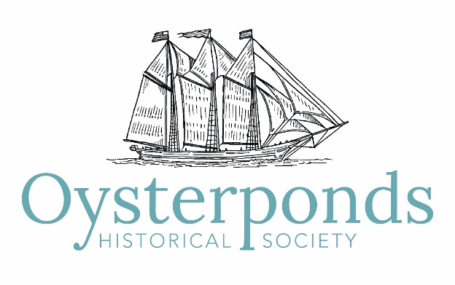

Minutes of Board of Trustees Meeting
July 21, 2019

Attendees: Co-Presidents Leslie Koch and Ed Caufield; Executive Director Sarah Sands; Trustees Sandra Saiegh, Allison Forstmann, Lydia Irving, Diana Whitsit, Leslie Cohen, Steve Rotella, Ann ffolliott, Robert Hanlon, Suzanne Gluck, Ellen Zimmerman, Howard Shainker, James Harris, Jeffrey Davis, Christine Churchill, Karin Constant

1. The meeting was called to order at 9:05 am.

2. Approval of Minutes
A motion to approve the minutes as amended from the May 19, 2019 board meeting was unanimously approved.

3. President’s Report
Co-Presidents Leslie Koch and Ed Caufield reported the following:
- Sarah Sands was introduced and welcomed as the new executive director for the Oysterponds Historical Society.
- Event planner, Maria McBride has been hired for the 2019 Summer Benefit.
- People can contact Catherine Chaudhuri if they are interested in volunteering for the Summer Benefit and Art Auction on Saturday, August 3rd.
- There was a large attendance at the New Wave of Modern Architecture on the North Fork lecture on Saturday, July 20th.
- The Introduction to Weaving program with Ellen Zimmerman went very well. There is consideration of repeating this program again in the fall.

4. Executive Director Report
Executive Director, Sarah Sands reported the following:
Administrative -
- Met with Bookkeeper and Treasurer to learn current practices.
- Financial transition issues – One staff signatory, 2 signatures on all checks and switch to a credit card rather than existing debit card.
- Rewriting job descriptions for consistent formatting and current practice.
- Looking into hiring for facility cleaning and Sunday openings.
- Moving to Google Suite from Outlook which will help with the ease of access on cell phones and other products.
Resource Development
- North Fork Fresh 2019 netted $23,699.00 and ticket sales to date for the Summer Benefit are $22,700.00.
Marketing
- Adding Twitter to social media postings - Plan for on-going daily postings on Facebook, Twitter and Instagram.
- Times Review and North Forker featured North Fork Fresh
- The Suffolk Times interviewed Sarah Sands.
What’s Ahead?
- August 3 – Summer Benefit and Art Auction
- September 13 Lecture – The USMS Georgia, 4pm
- November 30 to December 15 – Beach Plum Shop
- December 7 – Holiday House Tour, 12pm
- December 7 – Webb House Holiday Party, 5:30pm

5. Finance Committee Report
Treasurer Allison Forstmann reported the following:
- North Fork Fresh Financial Report – 2019 (revenue: $41,925/expenses: $18,226) vs 2018 (revenue: $41,320/expenses: $17,667). Outcome is as budgeted within $584.
- Budget – We are maintaining the Budget, with the previously predicted Salary/Benefits increase and with Contracted Services requiring payment/with repayment to follow. Aside from these two areas of expenditure, we are status quo for the cash flow crunch this time of year. We also continue to have the predicted deficit in the budget caused by our growth; Leslie Koch and Ed Caufield continue discussing Board participation.
- Investment Service Providers – The Committee completed a comprehensive analysis of five investment service providers and moved into an “interview” stage. The Committee completed the interviews on July 2nd, and then voted at the same meeting to enlist the services of Wells Fargo/Michael Ventura. Wells Fargo has a “transition plan” and will begin the process upon acceptance of the Board of our recommendation.
- Policies – The Finance Committee is currently not drafting policies. Executive Director, Sarah Sands, will be drafting a comprehensive policy that includes passwords, debit/credit card usage, signatory, procurement, and transition.

6. Buildings and Grounds Committee Report
- The minutes of the Buildings and Grounds Committee meeting on July 2nd were attached to the agenda.
- Webb House roof replacement will begin this fall.
- The next meeting is scheduled for August 6th at 9am in the schoolhouse.

7. Program report
- The Pre-Heritage Day Decoration Activity was very successful.
- The possibility of a September House Tour of the houses included in the New Wave of Modern Architecture on the North Fork is being considered.
- The September and October fall programs are: Bait to Table-Clams in Oysterponds, An Introduction to Weaving with Ellen Zimmerman and Rum Running-Talk and Tasting with historian Amy Folk and mixologist Paul Monahan.

8. Events
- James Harris and Leslie Cohen reported that the Summer Benefit and Art Auction on Saturday, August 3rd is in good shape. Live auction art is being donated by Arden Scott, Leo Villareal and Laura Owens. Silent auction art and non-art items continue to be donated.
- A suggestion that some of the ship models that have been restored through the Maritime Collection Conservation Fund be on display at the Summer Benefit.

9. New Business
- The Nominating Committee is beginning to consider candidates to replace Board Members whose term will be expiring. The committee is seeking people who are interested in supporting the mission of the OHS and have an interest in being involved in event planning.
- The idea of having a book signing party for Ned Baldwin at the Houseman Dinner was suggested.

10. Adjournment
There being no further business the meeting was adjourned at 10:10 am. The next meeting will be on Sunday, September 21, 2019 at 10:30 am.

