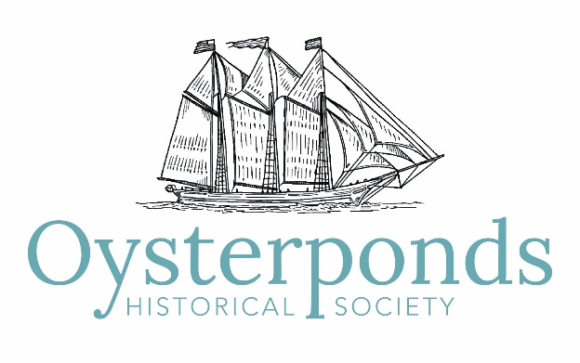

Minutes of Board of Trustees Meeting
Sept 19, 2019

Attendees: Co-Presidents Leslie Koch and Ed Caufield; Executive Director Sarah Sands; Trustees Sandra Saiegh, Allison Forstmann, Diana Whitsit, Leslie Cohen, Steve Rotella, Ann ffolliott, Robert Hanlon, Suzanne Gluck, Ellen Zimmerman, Howard Shainker, James Harris, Christine Churchill

1. The meeting was called to order at 10:30 am.

2. Approval of Minutes
A motion to approve the minutes by Bob Hanlon and seconded by Ellen Zimmerman was unanimously approved.

3. President’s Report
Co-Presidents Leslie Koch and Ed Caufield reported the following:
- Leslie noted the success of our summer events and programs.
- Nominations for Board members were requested particularly for Summer Benefit Chair and Summer Benefit Art Chair.
- The past Chairs of the holiday party are willing to participate on the committee but feel they need to step down. Issues include the wear and tear on Webb House and the extensive time commitment for volunteers in decorating. The suggestion was made to move the event to Poquatuck Hall, simplify it possibly making it a free volunteer appreciation event for all volunteers. A new chair will be recruited and type of event and location decisions will be decided by the new Chair.

4. Executive Director Report
Executive Director, Sarah Sands reported the following:
Administrative
- Change to a new IT service that would result in savings of nearly $5,000 annually was presented. A switch from a hardware- based system to a Virtual Private Network using Dropbox can be accomplished with existing computers. Howard Shainker offered the advice of his company.
- Move of the office and 3 staff members to Vail house would cost $2,690. This expense would be partially funded by the balance of $2,400 of the Gardiner grant that was not used for the Collections Care Plan preparation.

Resource Development
- The final financial report for the Summer Benefit indicates a net income of $118,061.
- A 4-page newsletter featuring our use of Maritime conservation Funds followed by an annual appeal featuring a story about L. Vinton Richards granddaughter and her research in our archives will be mailed to 1,400 households. It was suggested that appeals include the intended use of funds, be mission-focused and include the phrase “personally significant.”
- The Griffin Giving Circle, based on a successful giving circle donation from board members in 2018 & 2019, will seek 2020 pledges from Board members and selected community members. It will have 4 levels of donations and include a membership, North Fresh Sponsorship, Summer Benefit sponsorship, Holiday Party underwriting and an annual gift.
What’s Ahead?
- September 13 Lecture – The USMS Georgia, 4pm
- Sept 28 Weaving with Ellen Zimmerman
- Oct 19 Rum Running with Amy Folk
- November 30 to December 15 – Beach Plum Shop
- December 14 – Holiday House Tour, 12pm
- December 14 – Webb House Holiday Party, 5:30pm
(Holiday House Tour and Holiday Party dates have been verified with Sara Olmstead)

5. Finance Committee Report
Treasurer Allison Forstmann reported the following:
- Budget (Update):
We are maintaining the Budget, with the previously predicted Salary/Benefits increase and with Contracted Services requiring payment/with repayment to follow. Aside from these two areas of expenditure, we are status quo for the cash flow crunch this time of year. We are finalizing the budget comparison and beginning to prepare the Budget for 2020.
- Investment Service Providers (Update):
All rfp applicants, as well as Merril Lynch, have been notified/thanked in writing for their applications (and service, in the case of Merril Lynch). Sarah (Sands) has begun the transition process with Wells Fargo.
- Policies:
The Finance Policy has been drafted by Sarah (Sands) and has been made available for Board review in today’s Board packet. Any comments and concerns will be addressed at the next regular/monthly Finance Committee meeting on Tuesday, October 8th. The final version will be voted at the next Board meeting on November 17th. It was suggested that include a credit card use policy and consider seeking peer organization input particularly Sylvester Manor and Gardiner Foundation in cases where they may have existing policies that we can mimic. Ellen Zimmerman will provide input regarding document retention policy.
- Year-end/Transition
Sarah (Sands) has a timeline for the remainder of the year and includes timing and requirements for the November Board meeting, the Annual meeting, the 990 filing and the 2019/year-end reporting (January Board meeting).

6. Audit & 990 reports
- The audit is ready for distribution to the Board in Oct. There is some question regarding art donations valued over $5,000 being included on the 990. IRS regulations do not allow a non-profit from placing a value on a donated item.

7. Committee Reports
Buildings and Grounds Committee Report
- The minutes of the Buildings and Grounds Committee meeting on were attached to the agenda.
- Webb House roof replacement is scheduled to begin on Sept 30th
- New committee members will be recruited.
Program Report
- All programs were well-attended particularly the North Modern roundtable with a standing room only crowd.
- Children’s programs in Aug were popular and met with enthusiasm by children and adults.
- The Clam to Table event hosted 40 people with visitors from Montauk, Shelter Island, Cutchogue and Westchester county.
- The September and October fall programs are: An Introduction to Weaving with Ellen Zimmerman and Rum Running-Talk and Tasting with historian Amy Folk.
Education Report
- A report was attached.
- A two-day program celebrating the OHS 75th birthday complete with birthday cake was presented for children in the Oysterponds School Summer Program.
Collections Report
- A Collection Care Plan steering committee will start meeting soon with a small committee of Ann ffolliott, Sarah Sands, Amy Folk. Ted Webb and Charles Dean will also be invited. Other committee members will be brought in as needed.
8. Old Business
- Leslie Koch reported that we have reached out to the Blacks and decided to erect signs at the entrances to Poquatuck Park as promised in 2016 indicating the park rules that were outlined in the original deed of transfer from George Latham to OHS.
- Ellen Zimmerman reported that EMCA has been successful in obtaining approval for historic corridor status for the Main Road in East Marion.
9. New Business
- The resurrection of admission fees was discussed in the context of benefits for members. Other benefit suggestions included 10% discount in the Shop, reciprocity with other societies, organized activities for members such as tour of other historical societies and discount at Burton Books. It may also help with member recruitment to indicate that it is funding a project.
10. Adjournment
The next meeting will be on Sunday, November 17, 2019.

